REPORT ON SURVEY RESULTS
14 January 2021

- Foreword by Michael Ratcliffe MBE – Chairman of REACH
On 19th November 2020 Restore Emergency at Cheltenham General Hospital (REACH) launched our own “Fit for the Future” survey. The rationale for producing the survey was following concerns that the One Gloucestershire Fit for the Future survey, had been constructed in such a manner that the results could be used to justify a decision which respondents would not have supported. We are delighted to be able to share the full results of this survey in this report.
It is worth reflecting at this point what the purpose of the “Fit for the Future” consultation is. Gloucestershire Hospitals and Clinical Commissioning Group would like to reorganise hospital services between Gloucestershire Royal Hospital (GRH) and Cheltenham General Hospital (CGH).
They have created the concept of “Centres of Excellence”. This concept is essentially centralisation of a particular specialty or service on either the GRH or CGH site, meaning that that service would no longer be available in the other hospital. Whilst the hospital has suggested that this would provide “excellent” care, there is little to suggest that the quality of care in the current configuration is anything other than good or excellent.
Whilst the centralisation of any particular specialty might improve the quality of care slightly, such a reorganisation would also inevitably mean that half of the County would need to travel further for this specialist care in each circumstance.
Some of the centralisations would require very large numbers of inpatient or overnight hospital beds (e.g. the highest number being acute medicine, followed by emergency surgery and trauma orthopaedics), whereas some of the proposals, such as day surgery, would require no inpatient beds, as the definition of day surgery is that patients go home on the same day. Understanding the implications for hospital bed requirements with each proposal is important, as it is essential that the hospital beds on both sites are used effectively for the benefit of all the local population.
One point that we cannot nor should we overlook, is the fact that the Consultation does not include the Cheltenham A & E Department, as the Hospital Trust has committed itself to re-opening Cheltenham General A & E after the pandemic. Some of the proposed changes however could undermine the future viability of Cheltenham General A&E.
We launched our own survey, to gather the real preferences of those local people in Gloucestershire and surrounding areas, who will be affected by these proposals. We would like to thank everybody who took the time and trouble to respond to our survey.
The issues addressed in the survey are complex and as a consequence required quite a bit of explanation, hence the length of our survey.
We believe it is vital that the public can actively engage in this consultation. We are not convinced that the One Gloucestershire survey enabled the public to express clear responses to some of the key points, which is why we chose to produce our own Fit for the Future survey.
Through these findings, the public has made their feelings very clear and we urge One Gloucestershire to take these into consideration during their deliberations.
- Survey Results
The findings from this survey are based upon 335 full or partial survey responses.
Question 1 ACUTE MEDICINE (ACUTE MEDICAL TAKE)
The Trust would like to centralise the admission of all emergency medical patients to GRH. Until the recent temporary COVID changes, emergency medical patients (such as those presenting with heart problems, pneumonia, stroke, sepsis, confusion etc) were admitted to both GRH and CGH. This change would mean that medical emergency patients from the Eastern half of the County would have to travel further for care.
Please note that the number of acute medical patients constitutes by far the largest number of emergency admissions in any hospital. In previous years, daily medical admissions of between 30 to 60 patients at both Cheltenham and Gloucester would not have been unusual, particularly during the winter period. Hence, centralising emergency medical admissions to GRH will require a large number of hospital beds at that site. This needs to be borne in mind when considering other proposals, which might centralise inpatient services further at GRH.
Do you agree with the Trust’s preferred option of centralising acute emergency medical patients on to the GRH site?
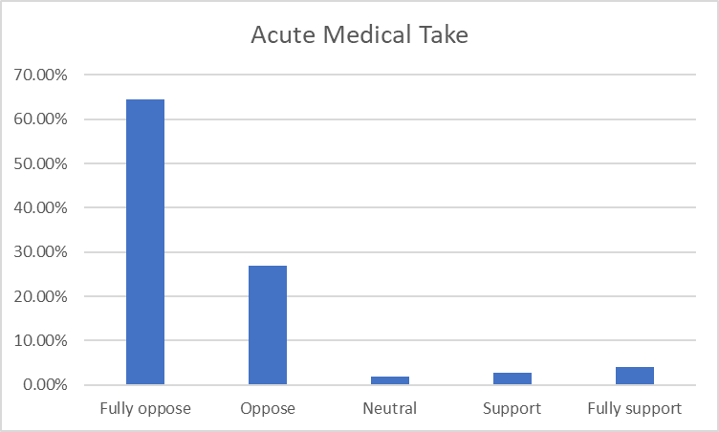
The public response has been overwhelming, indicating that the people do not support centralisation of the acute medical take or emergency admissions at GRH. Whilst a few respondents supporting the centralisation have pointed to potentially higher standards of specialist care, the majority of respondents have concerns about lack of bed capacity at GRH, travelling and access to care. One respondent succinctly said that “It is hard to imagine a General Hospital without acute medical beds. Cheltenham is a General Hospital, it needs to supply beds for both surgical and medical patients. Removing medical beds from Cheltenham is essentially downgrading this hospital and masking it less important, like asset stripping!”

The response to REACH’s public survey indicates that the majority of the public would like to see acute emergency medical patient admissions retained at CGH. One Gloucestershire’s argument that centralising emergency medical specialists onto one site to improve care has not been persuasive enough to sway public opinion.

REACH recognises that there may be other factors influencing One Gloucestershire’s preferred option, such as staffing and other resources. The Government has pledged to increase nursing and doctor numbers. This has already led to a larger number of medical graduates as well as a large expansion in medical school places and universities offering medical training. Hence any current staffing pressures are likely to be ameliorated in future.
Sample of additional comments:

“If this accounts for largest number of admissions surely danger of GRH being overwhelmed?
I absolutely disagree with A&E services being centralised at GRH, you only have to look at what has been going on recently over there to see the mayhem it would cause. It puts unnecessary pressure on the staff at GRH.
I had to go into hospital as an emergency. No ambulance available to take me to GRH. The paramedic took me in his car. GRH full to capacity; lay on a trolley in a corridor for 3 hours before being seen. I could have died and no one would have known.
Ridiculous idea. Preposterous to even think this could work without an increase in bed space. Will this also not increase the workload of the staff at GRH? Are there plans to adequately staff GRH? Nursing staff are leaving and are filled with expensive agency staff. I suspect there is a similar issue with the staffing levels of the doctors. Or are they expected just to get on with it whilst compromising care of constituents.
It is admirable to want to keep all your experts on one site. However, I fear the sheer numbers of people needing to be seen at any one venue are not practicable. Better, surely to see people at two sites, meaning they can be treated in half the time. If in a critical condition, then surely any extra waiting time endangers the patient. That includes transit time.
International evidence shows centres of excellence provide better care for patients. It also helps to recruit the best people to work there. If you have a serious heart attack in Gloucestershire at present you may be diverted to Bristol as this is where the best treatment is available. What is wrong with wanting that here in Gloucester.”
Question 2 CENTRALISATION OF EMERGENCY GENERAL SURGERY AT GLOUCESTERSHIRE ROYAL HOSPITAL
General surgery is a specialty in its own right, and includes the care of patients with upper gastrointestinal (gullet, stomach, liver, and gallbladder), lower gastrointestinal/colorectal (small and large intestine), breast surgery, and vascular surgery (dealing with patients with blocked or diseased arteries and veins).
Up until the recent temporary COVID changes, patients requiring emergency general surgical care were treated at both GRH and CGH. Emergency surgical problems include appendicitis, peritonitis, inflamed gallbladders, bowel blockage, and internal bleeding. National audits showed that emergency patients at both sites received good or excellent care.
The Trust would like to centralise the admission and treatment of all emergency surgical patients at Gloucester and would like to close the emergency surgical service at Cheltenham. Centralising emergency general surgery at GRH would require a reasonable number of extra inpatient/overnight beds at Gloucester, and would free up the equivalent number of inpatient/overnight beds at Cheltenham, which could potentially be used for a number of major inpatient service.
This would particularly affect patients on the eastern side of Gloucestershire, who would normally access the emergency general surgery service at Cheltenham.
Do you agree with the Trust’s preferred option of centralising acute emergency general surgical patients on to the GRH site?
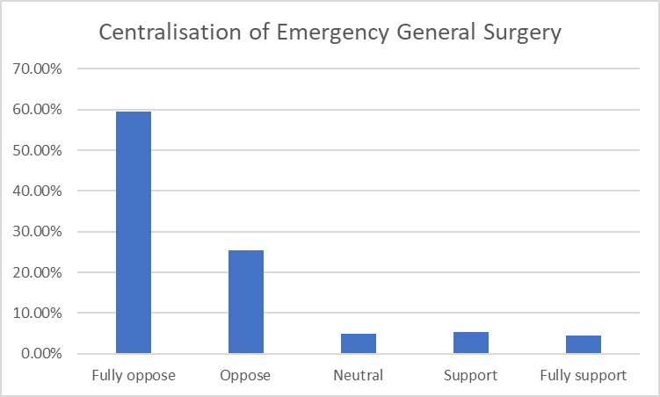
Public opinion is again not in favour of centralising emergency general surgery onto the GRH site. Only a small minority support One Gloucestershire’s preferred option.

The public response has cited concerns over lack of bed capacity at GRH, travelling & access times, the fact that emergency services were excellent previously, and a potential waste of nursing skills at Cheltenham for those nurse whose social circumstances prevent them from working at Gloucester. The increased pressure on Critical Care bed capacity at Gloucester was also highlighted as a concern, whilst the state of the art intensive care at Cheltenham would be under-utilised.

Supporters of the proposal indicate that cooperation and pooling of manpower between GRH and CGH surgeons at one site might lead to improved quality of care with quicker opinions for emergency admissions.
Sample of additional comments:
“Where are they going to get all the extra beds from, having been an inpatient last year when there were no beds available, I cannot see how this would work to patients’ advantage, in fact I can see people having to wait for ‘emergency’ surgery with all the risks to their lives that that would bring.

Both sites are capable of providing excellent services; dividing work between the two increases flexibility.

So, essentially work that was performed at 2 sites is now all going to be at GRH alone. Does that mean staffing is still the same as if catering for the needs of 2 hospitals but just at GRH or more likely the poor sods at GRH will be doing double the work they originally would have done. Whilst houses continue to be built and the population continue to expand. This is cost cutting surely whilst stretching I presume an already stretched workforce.

Centralising may be easier for people delivering the service, but means patients nearly always have to travel greater distances. This can mean extreme discomfort for some, me included, but a lot more stress for patients…

This will allow a fully staffed surgical team to manage these patients. They should not have to wait to be seen until a doctor can leave the operating theatre.

Surgeons presently working at CGH would join colleagues at GRH and be able to share experience and expertise. Cooperation of this sort is important. There is an unfortunate tendency for staff at different hospital sites to feel that they are in competition with each other. Cooperation is always preferable. Moreover, freeing CGH for elective procedures would avoid the all too frequent and distressing cancellation of routine surgery because of an influx of surgical emergencies.”

Question 3 CENTRALISATION OF PLANNED LOWER GASTROINTESTINAL (COLORECTAL) SURGERY ON ONE SITE
A large proportion of patients having planned lower gastrointestinal (colorectal) surgery are patients with large bowel (colon or rectal) cancer. These specialist surgeons also operate on patients with inflammatory bowel disease (ulcerative colitis or Crohn’s disease), as well as repairing large abdominal hernias (which are not suitable for day case surgery). Patients with other problems, such as ovarian, womb or bladder cancer may also require the specialist input of colorectal surgeons, as these particular tumours can grow around the large intestine.
Currently, this group of patients are treated on both GRH and CGH sites. Patients with ovarian, womb, bladder, prostate and kidney cancer have their cancer operations performed in Cheltenham, and there are no plans to alter this service. Centralising this service on a single site would require a moderate number of inpatient/ overnight hospital beds. Please note that the Cancer Centre for Gloucestershire, Herefordshire and Worcestershire (Three Counties Cancer Centre) is located at Cheltenham.
Do you agree with the Trust’s preferred option of centralising planned lower gastrointestinal/colorectal patients onto a single hospital site?
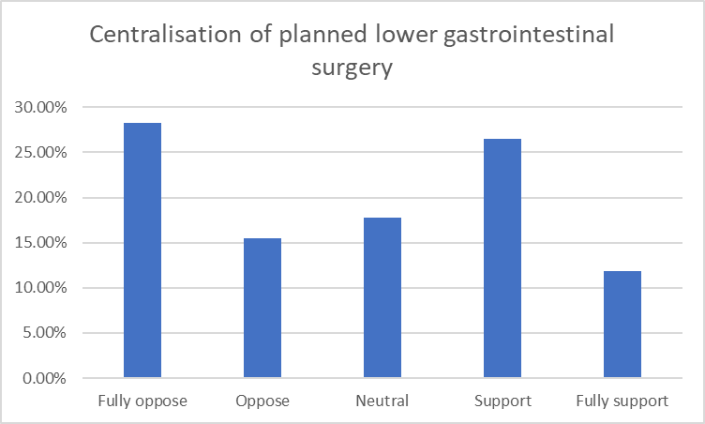
Public opinion on this issue was split. Notably a significant minority of people were neutral on this topic, as they believed that this should be available at both sites, or that answering this depended on the outcome of the emergency surgery debate. It would appear that the public would ideally prefer to have services as close as possible to home, whether this might be for emergency or elective care.

Supporters of this proposal, however, indicated that this should be centralised in Cheltenham as part of the Cancer Centre.
Sample of additional comments:

“Should all cancer work not be done at Cheltenham where the outstanding cancer service is situated or am I being simplistic?

It would be sensible to have this service at CGH with gynecological oncology.

Whilst there may be a case for centralising at Cheltenham - certainly not at GRH - this could only be considered in the light of decisions made on other issues. There seems to me the danger of progressively demoting Cheltenham as a centre of excellence, but there has also to be regard to the needs of patients in the west of the county.

We should have a choice, of hospital.

After opposing centralisation for the first 2 at Gloucester and Cheltenham is my local hospital I can’t agree for the people of Gloucester having the same problem of getting to Cheltenham.”
Question 4 If you do agree that it would be sensible to centralise planned lower gastrointestinal/colorectal patients onto a single hospital site, which hospital would best deliver this service?
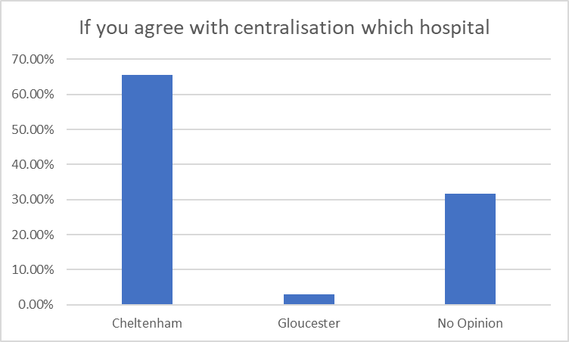
Supporters of centralising colorectal planned patients onto one site where they had an opinion, overwhelmingly indicated that Cheltenham should be the preferred site for such a proposal. Many respondents cited the importance of co-locating colorectal surgery with the Cancer Centre and patients with other cancer requiring colorectal expertise e.g .gynaecological and urological cancer patients. Some patients were neutral on this question, but this may reflect the respondents to the previous related question, who were not persuaded about centralisation.
Sample of additional comments:
“It is important to have experienced surgeons in cancer care who have done many operations. Keeping them on one site would mean that MDT meetings and on call would always have experienced staff. In fact I thought cancer care had to be in one site for an area now.

How will the gynae and urology consultants dealing with cancer be able to enlist the help of general surgeons if there are none on site?

Planned GI surgery should be concentrated on the site where there is already a Centre of Excellence for cancer treatment.

Whilst there may be a case for centralising at Cheltenham - certainly not at GRH - this could only be considered in the light of decisions made on other issues. There seems to me the danger of progressively demoting Cheltenham as a centre of excellence, but there has also to be regard to the needs of patients in the west of the county.
Elective patients currently have a poor service at GRH because if the chaos from the sheer number of emergency patients. They are not in a centre of excellence if the threat of being exposed to Covid is real. CGH colorectal combined with gynae/onc and urology define what a pelvic resection centre should look like. It is then in same site as oncology. Elective surgery is less likely to be cancelled and CGH can establish itself as a green site pelvic centre of excellence.”
Question 5 CENTRALISATION OF PLANNED DAY CASE OPERATIONS FOR UPPER AND LOWER GI SURGERY AT CHELTENHAM GENERAL HOSPITAL
This centralisation involves the care of patients having day case procedures such as routine hernia repair, gallbladder removal, haemorrhoid surgery, and endoscopy (gastroscopy and colonoscopy). Currently, these procedures are performed at Gloucestershire Royal Hospital, Cheltenham General Hospital, as well as in the community hospitals, such as Cirencester, Tetbury, Tewkesbury and Stroud General. Day case procedures are usually low risk operations, and can be delivered safely in both community and district general hospitals.
As these patients are day cases, there will be no requirement for overnight beds, as it is anticipated the patients will be discharged on the day of surgery. Therefore, centralisation of day case operations at Cheltenham General Hospital is unlikely to create significant numbers of free inpatient/overnight beds at Gloucestershire Royal Hospital.
Do you agree with the Trust’s preferred option of centralising planned day case upper and lower gastrointestinal patients onto the CGH site, as opposed to continuing day surgery in community hospitals and the two main hospitals?
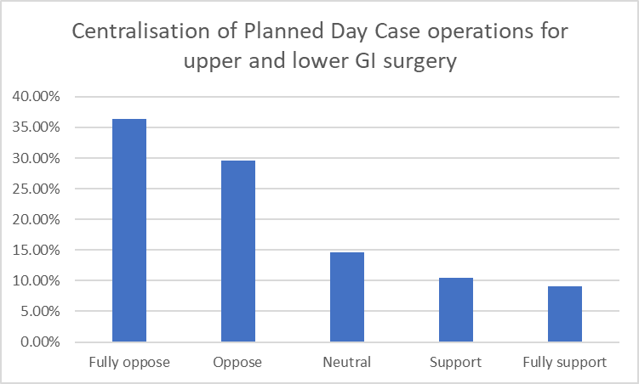
Public opinion clearly opposes the centralisation of daycase surgery at CGH. The public wants to have daycase surgery performed as close to home as possible, with the community hospitals. This would seem perfectly reasonable, as the delivery of daycase surgery in community as well as acute hospitals is entirely appropriate patients.
Sample of additional comments:
“With this service being offered at GRH and CGH as well as community hospitals it enables patients to have treatment nearer to their home

Spreading the workload of minor procedures over many local sites seems sensible and popular with the public who prefer to travel to their nearest site.
Again it seems to me that the system works well at present, and I know that things have to change with progress, but would this progress, if you have lots more patients waiting for day case operations in one place surely this lists will get longer. And it’s almost like the Trust is trying to downgrade CGH in the process, giving it less emergency work etc etc.

These day procedures should remain dispersed throughout all the hospitals to reduce demand on a centralised location, freeing up resources for more critical procedures. Dispersal of the service will serve local communities much better and help to ensure the viability of the community hospitals. It seems unnecessary to centralise this service and, (forgive me), appears a bit of a sop to CGH after proposed removal of so many of their services.”
Question 6 IMAGE GUIDED INTERVENTIONAL SURGERY (IGIS)
Image guided interventional surgery covers a number of specialties, which involve both planned and emergency care. The IGIS grouping, as described by the Trust, is not a grouping of specialties, which is widely recognised in its own right. The services, which the Trust would like to centralise, are described below.
Interventional radiology
Over the last 30 to 40 years, X-ray specialists or radiologists have performed procedures under local anaesthetic, which involve the insertion of tubes or drains. These procedures are known as interventional radiology. The most common type of procedure is to drain an infected blocked kidney either by inserting a tube from the bladder up to the kidney (ureteric stent) or by inserting a tube directly through the skin into the blocked kidney (nephrostomy). Less commonly, radiologists may need to insert tubes to drain a blocked gallbladder or liver and sometimes a drain may be needed to treat a patient with a large abscess inside the torso.
The Trust describes a “hub and spoke” model. The “hub” is the main central unit, which performs most of the procedures. The “spoke” is the secondary unit at the other hospital, which provides a facility for occasional emergency or urgent procedures.
The most common interventional radiology procedure involves draining a blocked kidney. Emergency patients with infected blocked kidneys most commonly present via the urology or oncology services, which are located in Cheltenham. A smaller number of emergency procedures are performed in Gloucester.
Where do you believe that the main interventional radiology centre or “hub” should be located in?
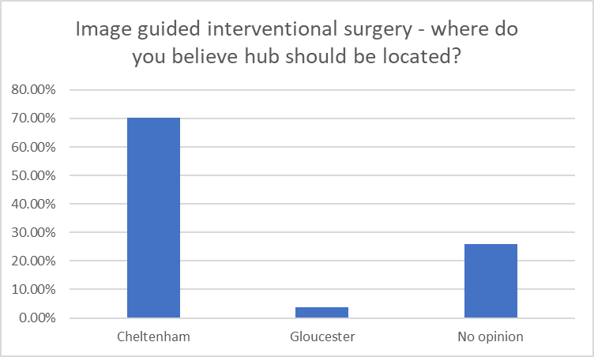
A clear majority of the public replies indicate that the main centre or hub for interventional radiology should be at Cheltenham. The respondents indicating “no opinion” generally said that this service should be provided at both hospitals. The Proposal from One Gloucestershire is for a “hub and spoke” model. Public opinion indicates that the main centre or “hub” should be at Cheltenham with a smaller service or “spoke” at Gloucester.
Question 7 INTERVENTIONAL MINIMALLY INVASIVE VASCULAR RADIOLOGY/SURGERY
Traditionally patients with blocked or diseased arteries were treated with an open operation to bypass or repair the affected artery. Over the last 20 years or so, radiologists and vascular surgeons have together developed new techniques to unblock diseased arteries from inside the artery itself. This is performed by inserting a tube or catheter into a good part of the artery away from the disease, guiding this catheter under x-ray control until it is in the diseased artery, and then opening up or repairing the artery from within.
Patients with vascular disease are usually treated either in a planned way or as an urgent procedure within a day or two of admission. Emergency treatment at night time is rarely required. About 6 years ago, the Trust built and commissioned a new state-of-the-art £2.5 million hybrid vascular interventional operating theatre at Cheltenham General. This purpose-built, large footprint operating theatre is regarded by many as being one of the very best in the South West of England.
Where do you believe that the main vascular interventional radiology/surgery centre should be located in?
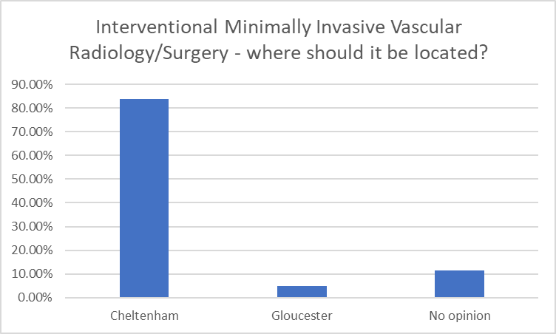
The overwhelming public response is that the interventional vascular centre should remain at Cheltenham, maximising the use of the state-of-the-art hybrid interventional operating theatre at CGH.
Sample additional comments:

“Given the installation of a £2.5 million facility at CGH six years ago it would be hard to justify moving the centre now

As the Trust built a new state-of-the-art £2.5 million hybrid vascular interventional operating theatre at Cheltenham General, it makes sense for this emergency treatment to remain in Cheltenham General. It would be a waste of taxpayers money to move this state of the art facility.
Millions of pounds have already been spent on this facility in Cheltenham already. It would be a scandalous waste of money to undo this. I understand that the majority of vascular surgeons also support it staying in Cheltenham.”
Question 8 INTERVENTIONAL CARDIOLOGY
For 30 to 40 years, heart specialists or cardiologists have been performing specialist interventional procedures to diagnose and treat heart problems. Initially, these procedures involved inserting a catheter or tube via an artery in the groin or elbow, so that special dye can be injected into the coronary arteries feeding the heart, thus diagnosing blockages or narrowing in the coronary arteries.
More recently, new techniques have allowed the cardiologists not only to diagnose blockages in the coronary arteries, but also to stretch the blockages back open (angioplasty) and to insert a self opening liner (stent) to keep the blockage open. These procedures are known as Percutaneous Coronary Intervention (PCI). PCI is usually performed as a planned day case procedure for patients with known heart disease, but sometimes these techniques are required in the middle of the night as an emergency for patients, who are suffering a heart attack. Emergency heart attack patients are usually diagnosed with a heart tracing performed by the paramedic ambulance crews, and this heart tracing can be forwarded electronically to the heart specialists as the ambulance leaves the scene.
Currently, the majority of the planned PCI procedures in Gloucestershire are performed at Cheltenham in the Hartpury Suite. Some of the emergency procedures for heart attack patients are also performed there. Until recently, some of the out of hours heart attack patients were treated in Bristol, but the Trust would like to develop a robust 24/7 service for the County. Importantly, the national guidance suggests that heart attack patients do better, if they are not delayed in a busy Accident and Emergency department.
Where do you believe that the main cardiac interventional radiology/surgery centre should be located in?
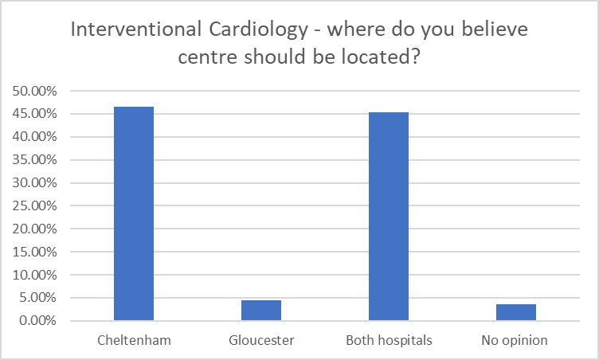
The public response was evenly split between having interventional cardiology at both sites or at Cheltenham alone.
Sample additional comments:

“I think it’s vital to have services like this available in both sites. Staff can work across sites as they currently do plus it’s in their contracts to. We shouldn’t bottle neck this service.

Having been treated in both hospitals for a heart condition, I have to say that I received excellent treatment in both. To me it would make perfect sense to have this facility on both rather than having to transport patients for treatment.

Cheltenham is already the Centre of Excellence for planned Cardiovascular surgery. My next door neighbour had a heart attack and had to be taken to Bristol. He died four days later. Who knows if he could have been saved if he had not had to be taken all the way to Bristol. Cheltenham should be developed as the Cardiovascular centre to reduce the number of heart attack patients who currently have to be taken to Bristol.”
Question 9 INPATIENT VASCULAR SURGERY
Vascular surgeons treat patients with blocked or narrowed arteries, as well as conditions such as varicose veins. The vast majority of vascular surgical inpatients comprise patients with badly narrowed arteries in the leg or disease in the main artery (aorta). The majority of arterial vascular operations are performed in a planned manner or at worst in an urgent scenario within 24 to 48 hours of admission. The numbers of emergency vascular operations in the middle of the night are now vanishingly small.
Although interventional vascular radiology/surgery procedures are performed in a number of patients with blocked or narrowed arteries, there is still a need for patients to have an open operation under general anaesthetic. Until the temporary COVID changes came in earlier this year, planned inpatient vascular surgery was performed at both hospitals, although the majority of interventional vascular radiology/surgical cases were performed in the £2.5 million state-of-the-art hybrid interventional radiology/vascular theatre at Cheltenham however the Trust is seeking to centralise this service on one site. The number of vascular inpatient beds required for this service is moderate.
Where do you believe that the main vascular inpatient surgery centre should be located in?
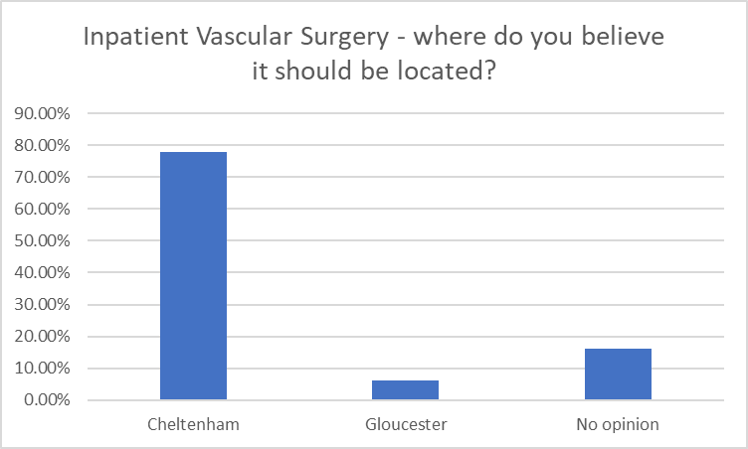
The overwhelming public response is that inpatient vascular surgery should remain at Cheltenham, so that the state-of-the-art hybrid vascular theatre can be used properly. The public do not believe that spending more money to replicate this facility at Gloucester represents value for taxpayers’ money.
Sample additional comments:

“As the Trust has a state-of-the-art £2.5 million hybrid vascular interventional operating theatre at Cheltenham General, it makes sense financially for it to remain there. It would be a waste of taxpayers money to move this.

I understand that vascular surgery was recently transferred from CGH to GRH as an 'emergency COVID measure'; staff and accommodation were drastically reduced. I can see no reason why this service should not be reinstated at CGH as soon as possible, It is a nonsense to waste the valuable and well regarded vascular operating theatre.

If there is already a state of the art centre for dealing with this at CGH surely there is absolutely no need to change it.”
Question 10 GASTROENTEROLOGY PLANNED INPATIENT SERVICES
The Trust is planning to centralise planned admissions for patients with gastroenterology (gut/ liver medical) conditions. The number of patients, who are admitted as inpatients/overnight for planned investigations for gut problems is very small. On the contrary, more patients are admitted with emergency gastroenterology problems, such as vomiting blood, jaundice etc. The management of these emergency gastroenterology problems is not the subject of this consultation.
There are advantages in co-locating the gastroenterology service with the major inpatient lower gastrointestinal/colorectal surgery service, as some patients may require attention from both the medical and surgical gut specialists. REACH believes that colorectal and bowel cancer surgery would be best centralised at Cheltenham alongside the Cancer Centre.
Where do you believe that the gastroenterology inpatient service should be located in?
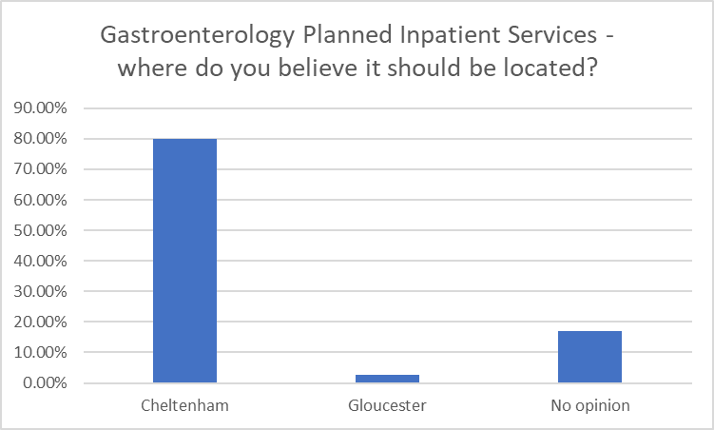
The vast majority of respondents indicated that the single site gastroenterology inpatient site should located in Cheltenham. Many cited that this is sensible, as it would be sited alongside the cancer centre in Cheltenham. Those who expressed no opinion indicated their preference for this service to continue at both sites.
Sample additional comments:

“Patients always benefit from a joined up approach to care and specialists on the same site makes for a less stressful experience

Makes sense to me if it is centralised alongside the Cancer Centre at Cheltenham.

It has already moved to CGH, there is Gastro cover every day in GRH to see any referrals.”
Question 11 TRAUMA AND ORTHOPAEDICS (T & O) INPATIENT SERVICES
Three years ago, the Trust Instituted a “Pilot Study”, which centralised orthopaedic trauma (fractured bones) patients at Gloucester, whilst concentrating planned orthopaedic surgery at Cheltenham (except for major spinal surgery, which remained in Gloucester). Although the Trust labelled this as a “Pilot Study”, the Trust has not presented any objective results of this “Pilot” for public scrutiny.
Whilst patients having planned orthopaedic operations in Cheltenham have generally had this performed efficiently, the results of the Trauma service in Gloucester have apparently not been as successful. Pressure on beds and operating time has led to continuing delays in performing surgery on trauma patients at Gloucester in a prompt fashion; delays in surgery can lead to worse outcomes. In spite of this uncertainty about whether the “Pilot Study” has been successful, the Trust would like to make this arrangement for Trauma services in Gloucester and planned orthopaedic care in Cheltenham permanent.
Do you believe that One Gloucestershire should be considering any proposals until the results of the “Pilot Study” are made public for proper scrutiny?
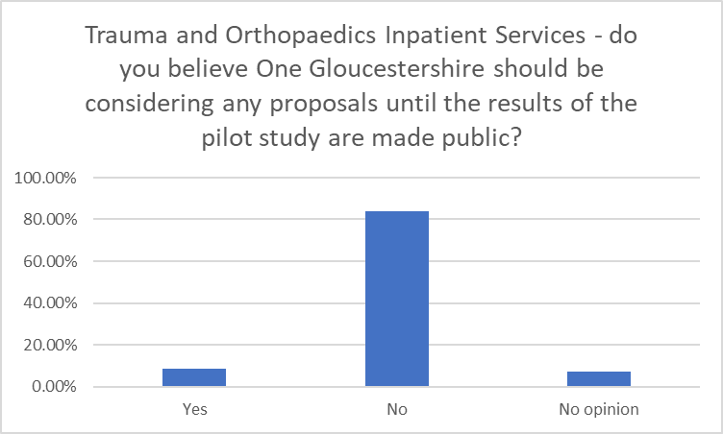
There was overwhelming public opinion that the results of the “Pilot Study” on Trauma and Orthopaedics should be presented for scrutiny prior to considering any proposals for a permanent reorganisation.
The public believe that One Gloucestershire should be transparent and share the data about trauma surgery outcomes for proper scrutiny.
Sample additional comments:
“To do anything other than publishing the results of a properly designed and unbiased evaluation would be a deceit of the highest order.

The Trust must see the results of the Pilot Study first, before making any further decisions on this. It would be reckless to proceed before any further facts, information and recommendations have been gleaned and shared with the public. Patient care and health could be compromised and it would be negligent for the Trust to allow GRH to continue when it is currently not coping with demand. Quality of care over quantity of patients seen is of paramount importance.

No if the pilot study has shown delays and pressure on beds then I think it would be very unwise to make Gloucester the place for Trauma services. If they do, then all orthopaedic trauma will end up there, (road traffic accidents for example). This means Cheltenham A&E will no longer be used for this purpose, essentially downgrading the A&E department at Cheltenham and making it a minor injuries unit. Again what sort of A&E will Cheltenham have?

I got ""bumped"" three times before getting needed surgery on this service, once when admitted and prepped. Not good.”
Question 12 Last but not least do you agree that the “Pilot Study” arrangement with Trauma based in Gloucester and planned orthopaedic surgery based in Cheltenham should continue as a permanent reorganisation, without the formal results of the "Pilot Study" being revealed?
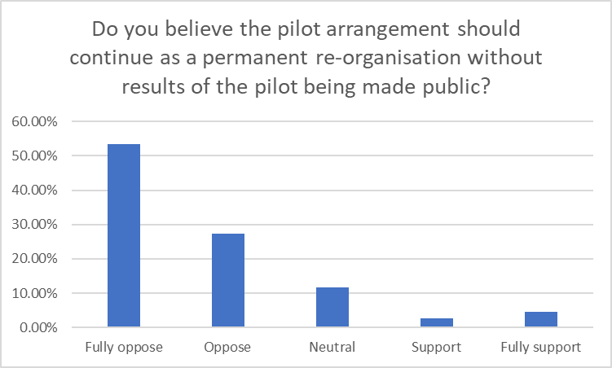
The public believe that the proposal to make a permanent reconfiguration along the lines of the “Pilot Study” should not be enacted until the results of the “Pilot” have been fully evaluated. Fewer than 5% of the respondents believe that it would be appropriate to proceed on such a basis.
Sample additional comments:

“They have a duty to reveal the results of the Pilot Study. Without it, one can only assume, it doesn't say what the Trust want it to.

We have to see the results of the pilot. If the pressure has proven too much for one hospital. I think the question is answered.

Having had major spinal trauma surgery in Gloucester there are serious issues - would need to see pilot first!

For the obvious reason that provisional management changes should be evaluated before being made permanent.
As a general addendum my experience at both hospitals is that whilst Cheltenham is certainly busy GRH is already under excessive pressure which potentially threatens patient care.

Evidence MUST be presented before any decision is made. I am very worried by this, (in some cases), non-evidential push by the Trust to 'beef up' the responsibilities of the GRH, whilst diluting those at CGH. I cannot see how their ambitions for GRH can be satisfactorily achieved without major investment and expansion of both buildings, equipment and staff. I am also concerned with the well-being of staff at Gloucester having to try and absorb the additional demand that would result from the Trust's proposals.”

Summary

REACH has recognised that the proposals in Fit for the Future are complex and will have a wide ranging permanent impact on healthcare provision in our County.

The implications of centralising emergency care have not, we believe, been explained fully to the public by One Gloucestershire. The concept of excellent care is indeed laudable, and REACH recognises the challenges of staffing as well as the impact of advances in patient care.

Nevertheless, the public have overwhelmingly stated that they would prefer, in general, care closer to home. The public understand that there are significant bed pressures at GRH, which would be amplified further by centralising of acute medicine and emergency surgery at GRH. The public know that One Gloucestershire cannot squeeze the proverbial “quart into a pint pot.”

The large number of extra inpatient beds required at GRH from the centralisation of emergency medicine and surgery are very substantial and are unlikely to be offset by proposals such as centralising day surgery at Cheltenham. The public are concerned that these proposals may downgrade Cheltenham and that proposals to centralise day surgery at Cheltenham might be regarded as a “sop” to public opinion. REACH believes that the excellent facilities and dedicated staff at both hospitals should be used efficiently and that happy and fully engaged staff can then provide the best care and service to the people of our County.

If One Gloucestershire wishes to proceed with its proposals to centralise emergency care at Gloucester in spite of public opinion, REACH believes that as much elective major activity should occur at Cheltenham, in order to utilise the beds, nursing expertise and importantly the excellent intensive care unit at Cheltenham. This public survey has shown that if there is a to be a centralisation of colorectal surgery and the vascular service, both these services should be located in Cheltenham.

REACH was concerned about the portrayal of Image Guided Interventional Surgery as a single specialty, when in fact this concept covers many disciplines. After explaining this to the public in non-medical language, the public have indicated that this should be located at Cheltenham. The exception to this is cardiac intervention, where the public indicated that this should either be a both sites or at Cheltenham.

The launch of Fit for the Future during the worst pandemic in living memory has caused concern among the public and REACH. The Government and healthcare community are concerned that we are likely to experience further future pandemics, or that the COVID virus may mutate significantly.

This COVID pandemic has wrought havoc to our healthcare system and caused the delay and cancellation of non COVID related healthcare for millions of people. REACH believes that any proposal for the future must include resilience planning for future pandemics. One Gloucestershire’s Fit for the Future proposals include no proposals to render our local healthcare system more robust and we would exhort our healthcare leaders to re-examine the proposals in the light of the catastrophic events of the last 9 months.

